# Lab Guide for BYO dCloud Lab

## Part 1 – dCloud Topology Builder Tool

1. dCloud Topology Builder:

<https://tbv3-ui.ciscodcloud.com/>

1. CEC login if prompted
2. Select “Topologies”:

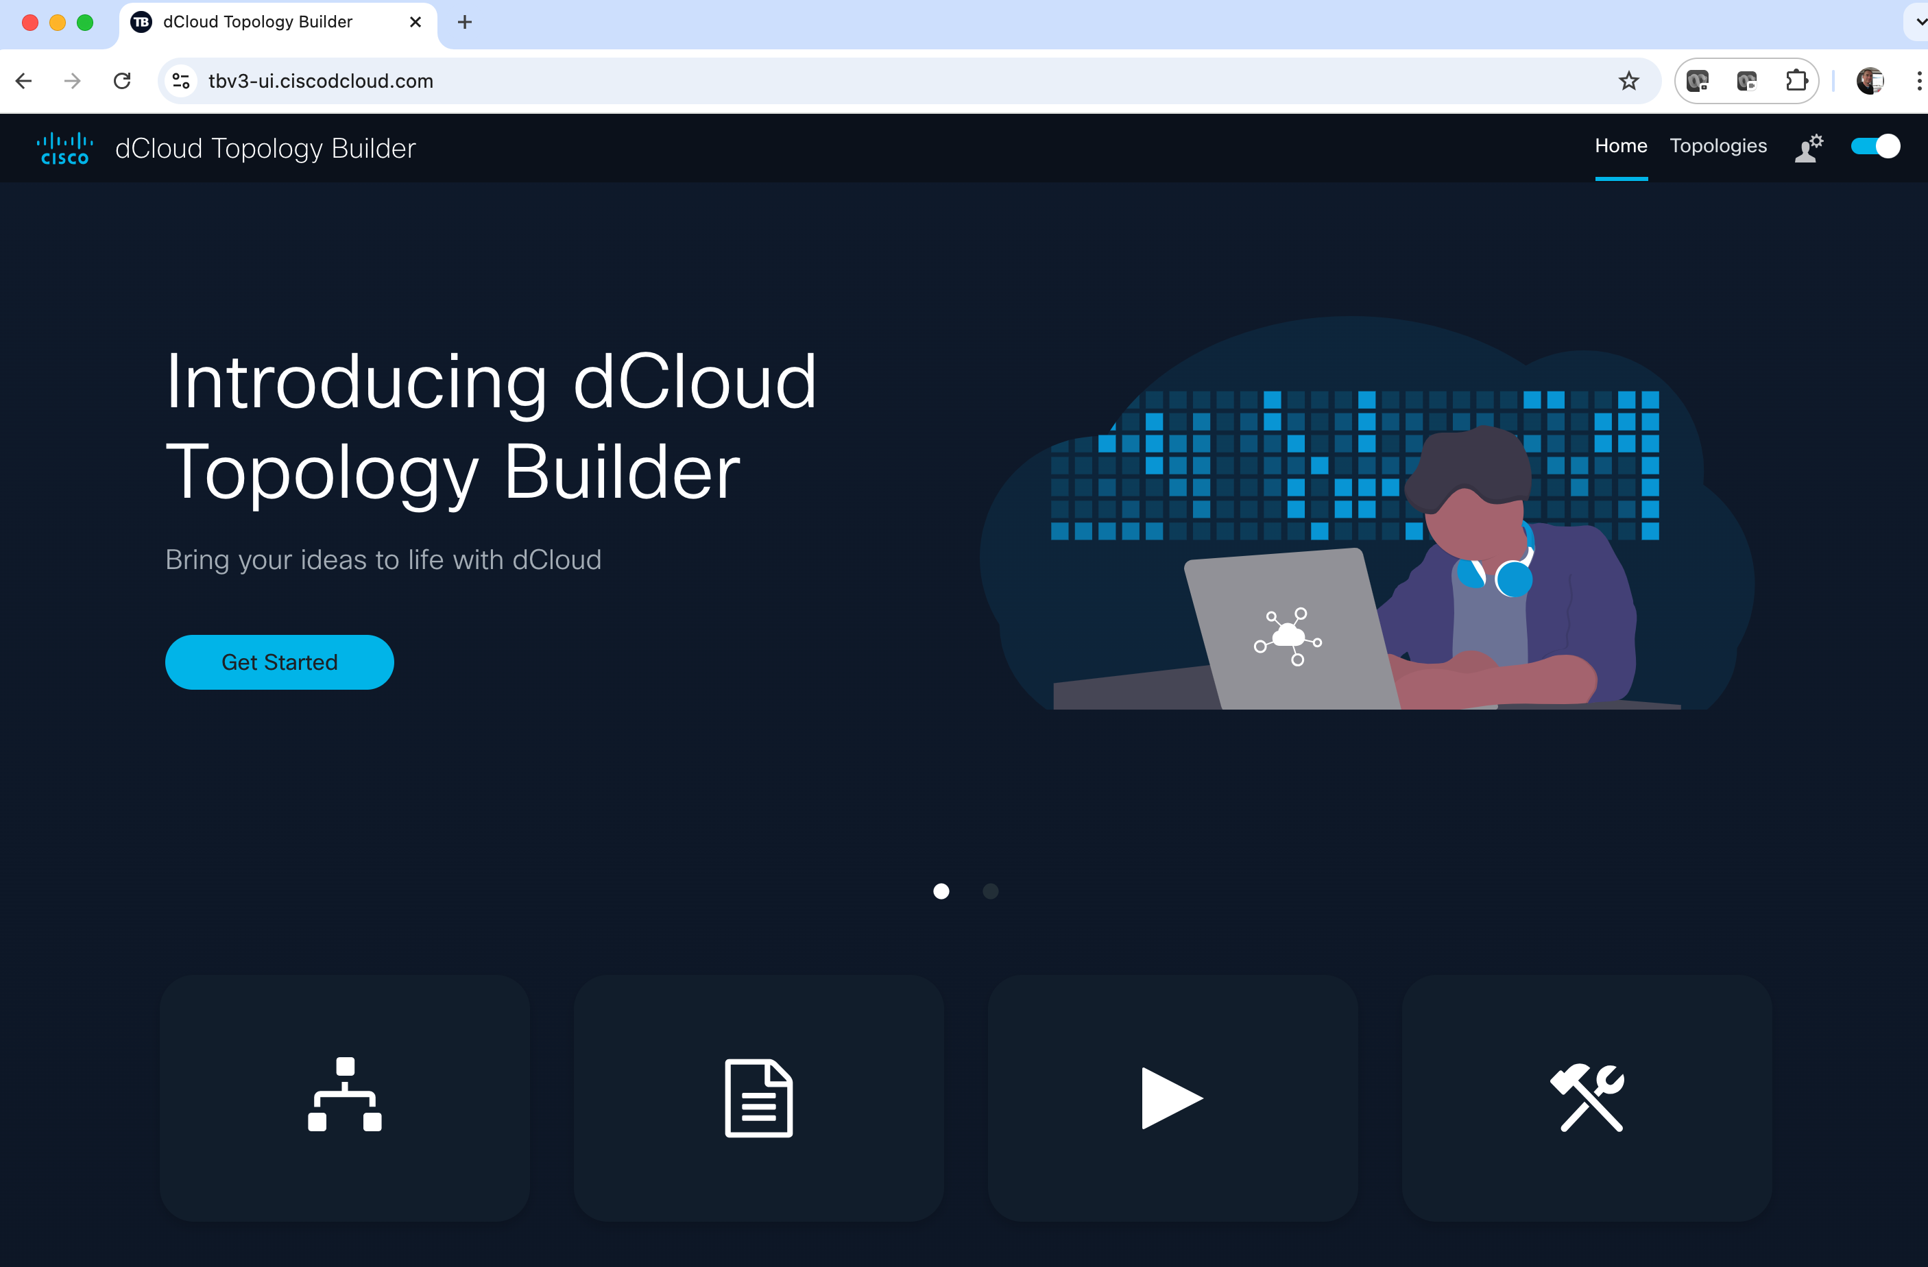

1. Select “Create”

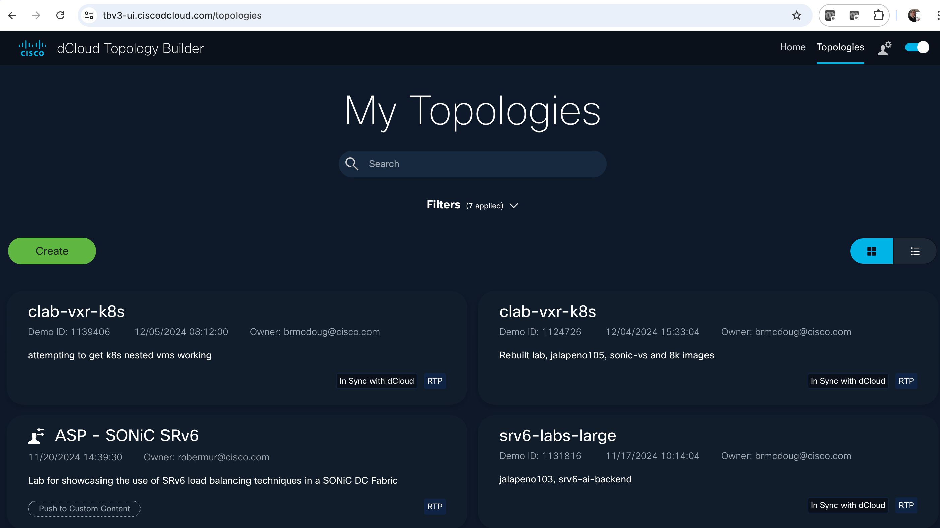

1. Select a Data Center (US East or West)

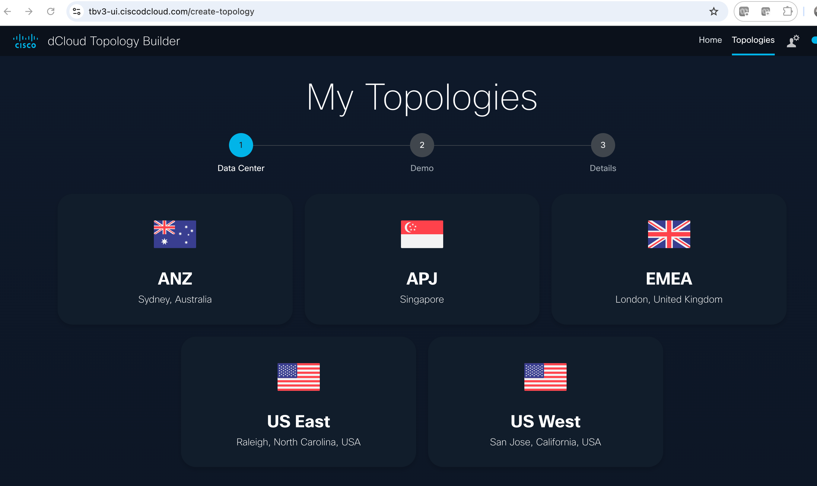

1. Select Blank/Create from scratch

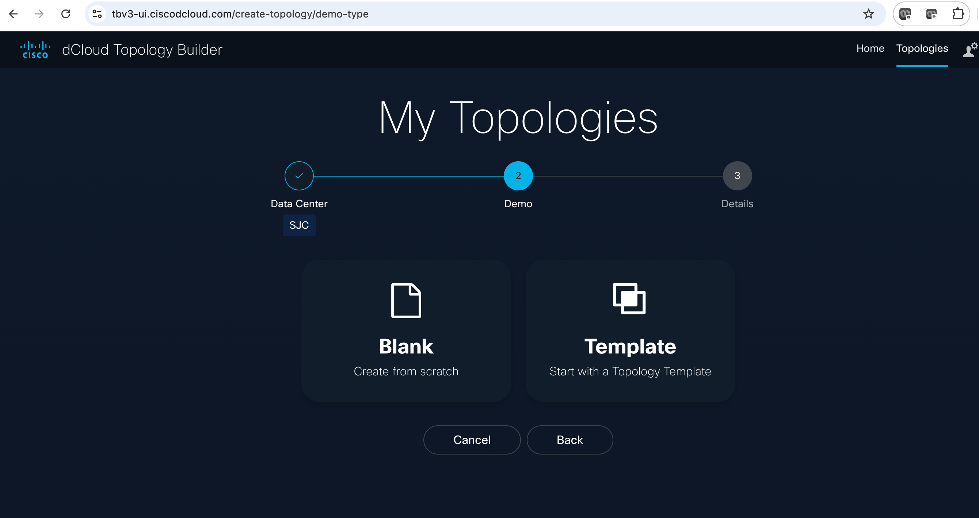

1. Name it and click “create”

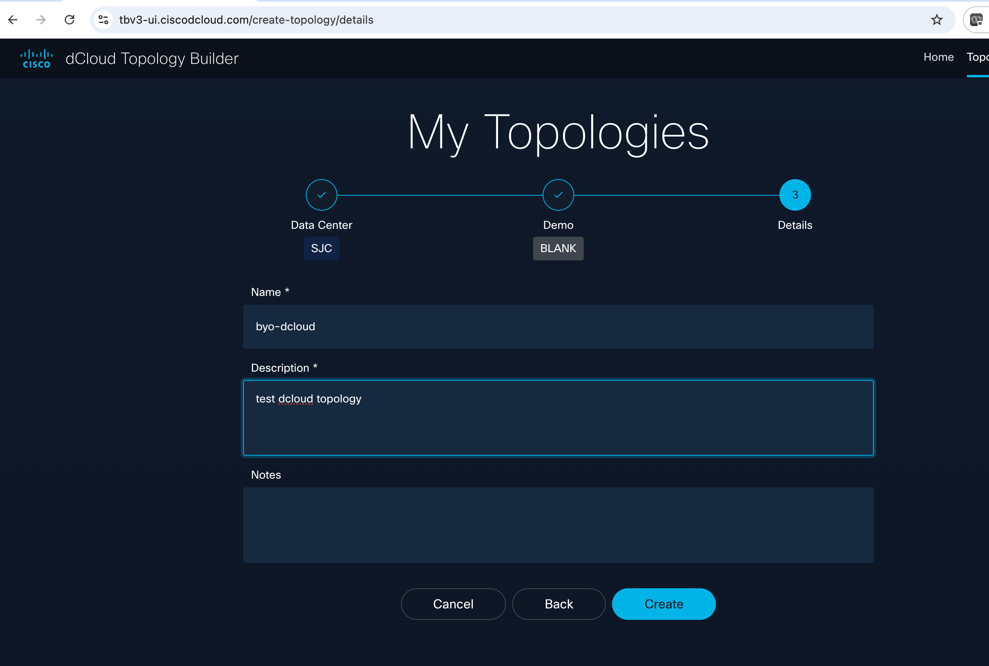

1. We’re going to build a very simple topology with one Big VM. Select “Virtual Machines”:

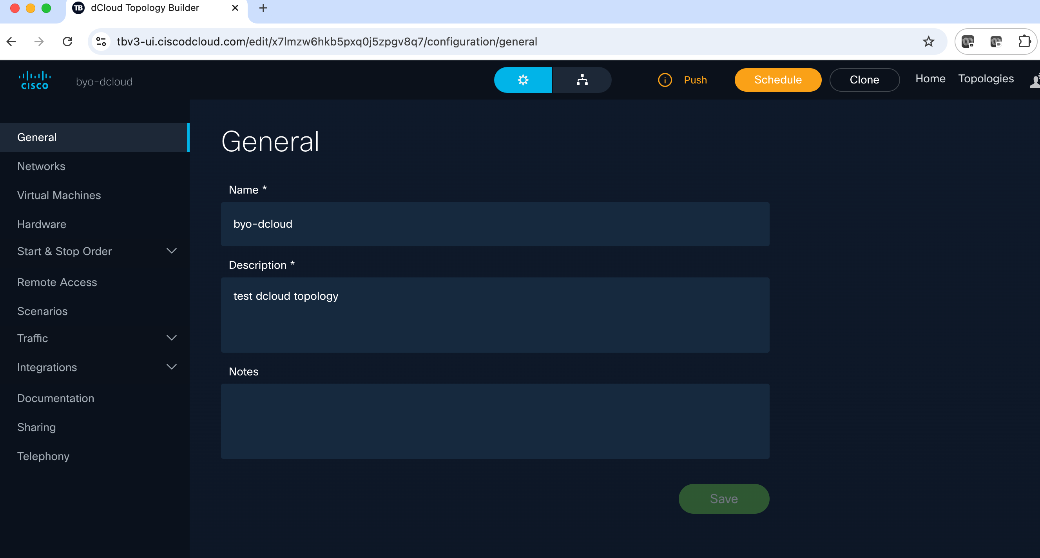

1. Select “New”

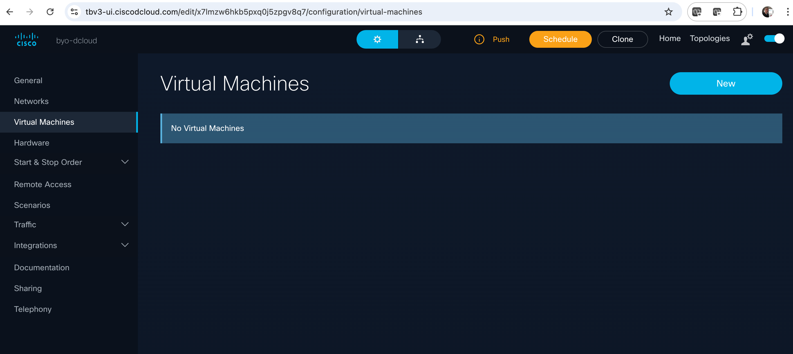

1. Search for “***ubuntu-22-04-server-80gb-preconfig***” (you can also search for just “ubuntu” to see other options

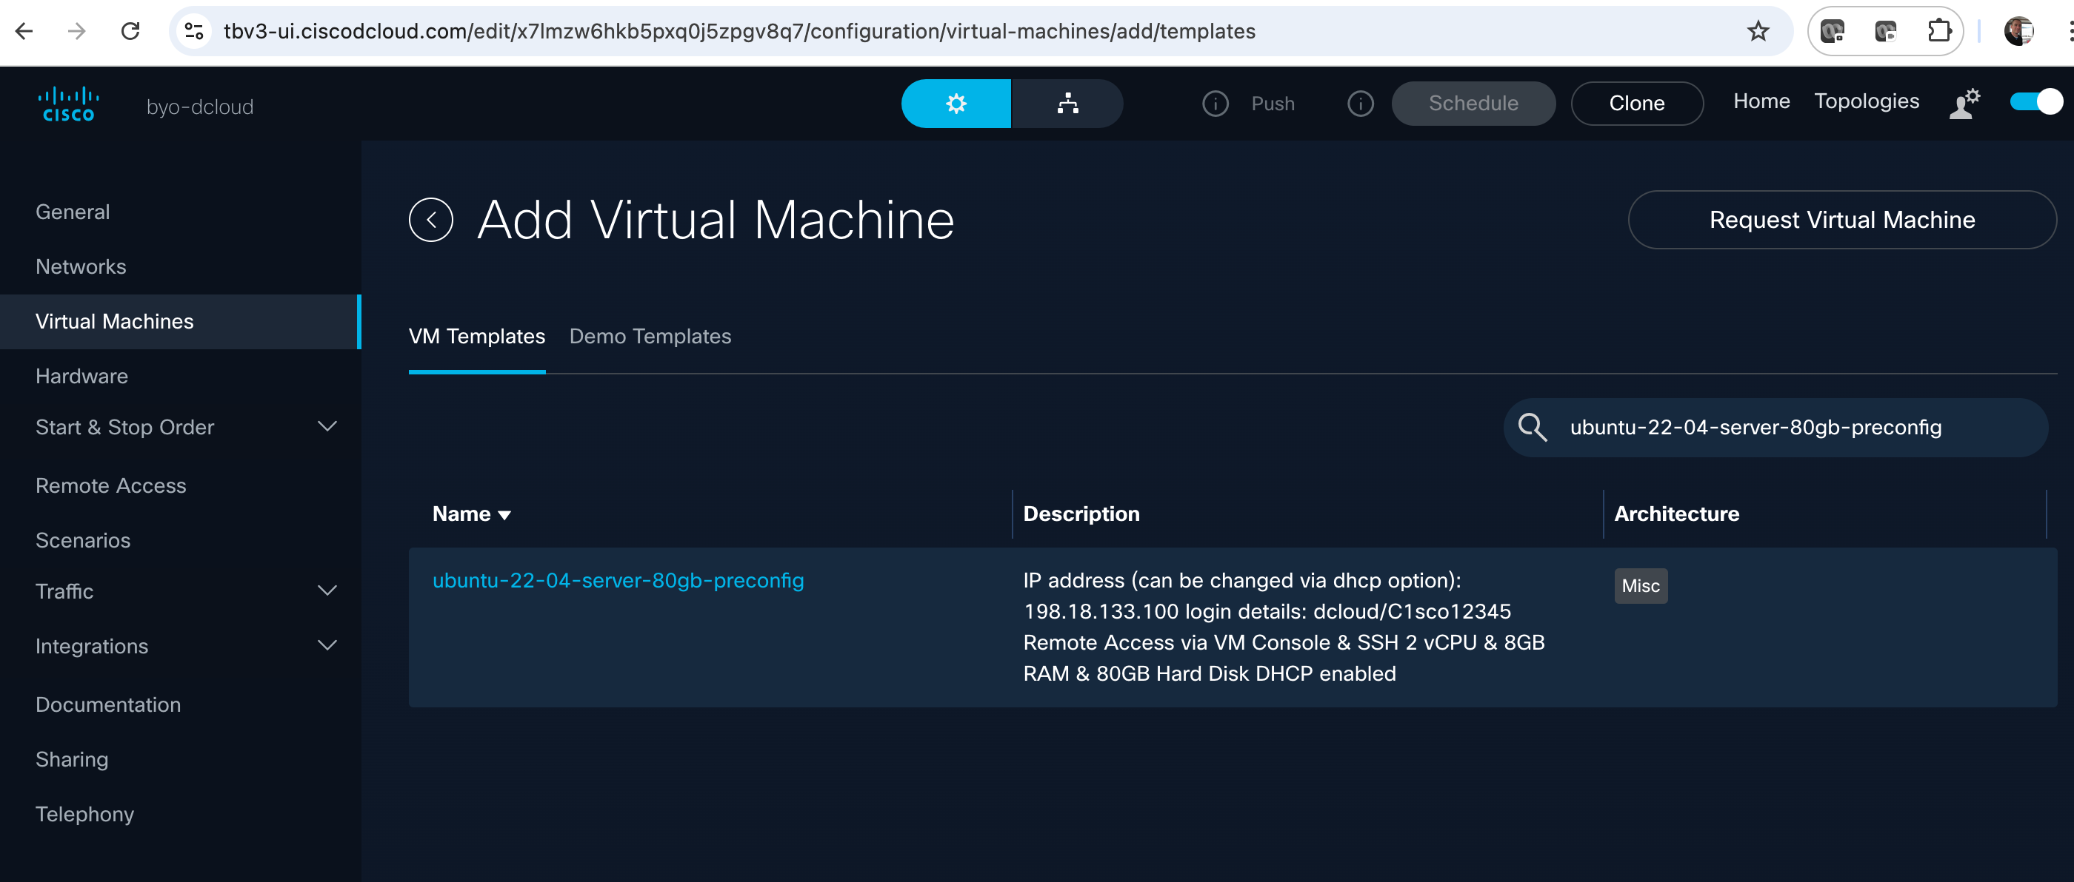

1. Select the VM template, then in the configure network screen select “Default Network” from the dropdown. Then click Add:

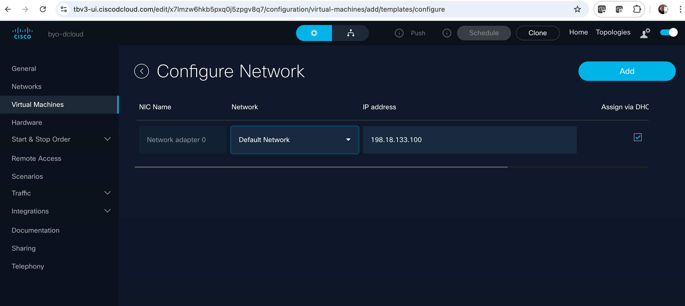

1. Virtual machine has been added. Now we want to edit it to increase memory and CPUs. Hover mouse/trackpad to the right of the screen as shown…select the pencil thing:

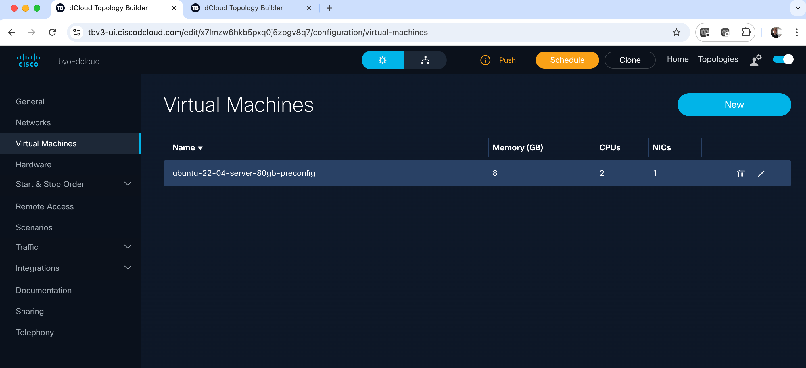

1. Change CPUs to 16 and Memory to 32. Note other options on this screen such as Nested Hypervisor (enable/disable) and Networking, etc. After editing CPU/Memory click “Update”

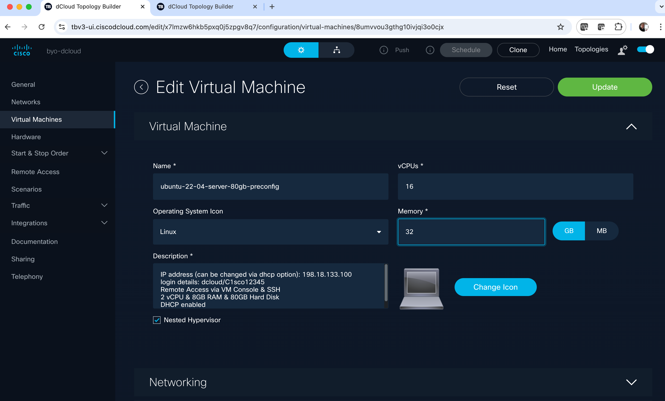

1. Go back to the “General” screen. You should see “Push” and “Schedule” lit up in Orange. Click “Push”

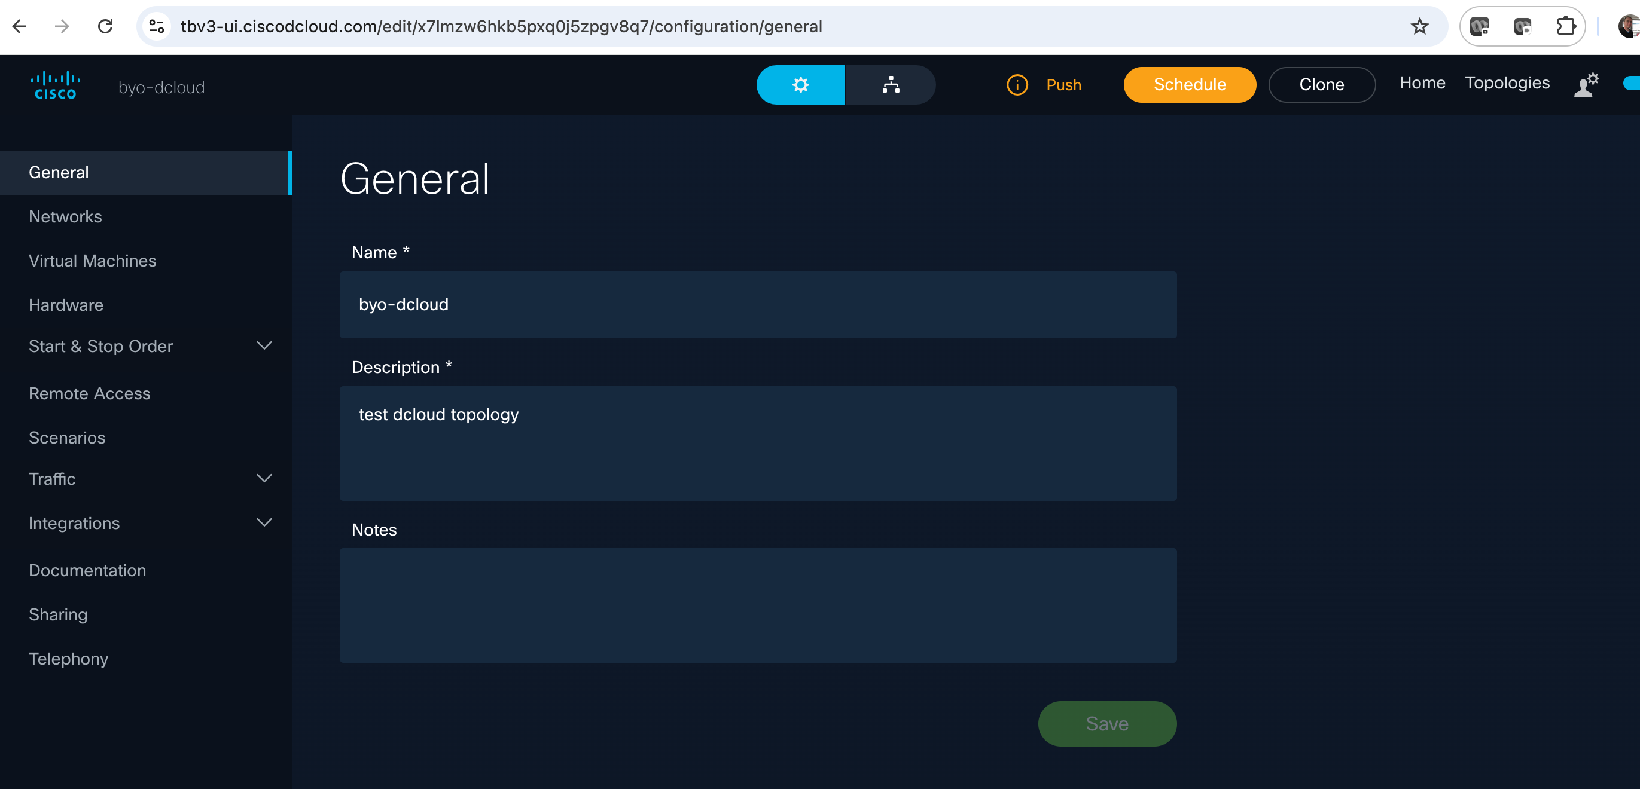

1. Click Save

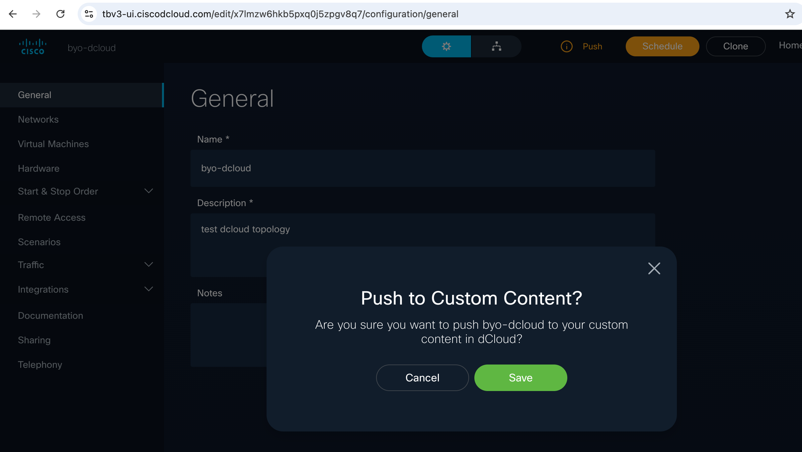

1. Your “topology” has now been pushed to dCloud (in this case SJC). For reference log into dCloud sjc or rtp:

<https://dcloud2-sjc.cisco.com/>

<https://dcloud2-rtp.cisco.com/>

1. Select “My Hub” at the top right, then “Custom Content” in the left side menu:

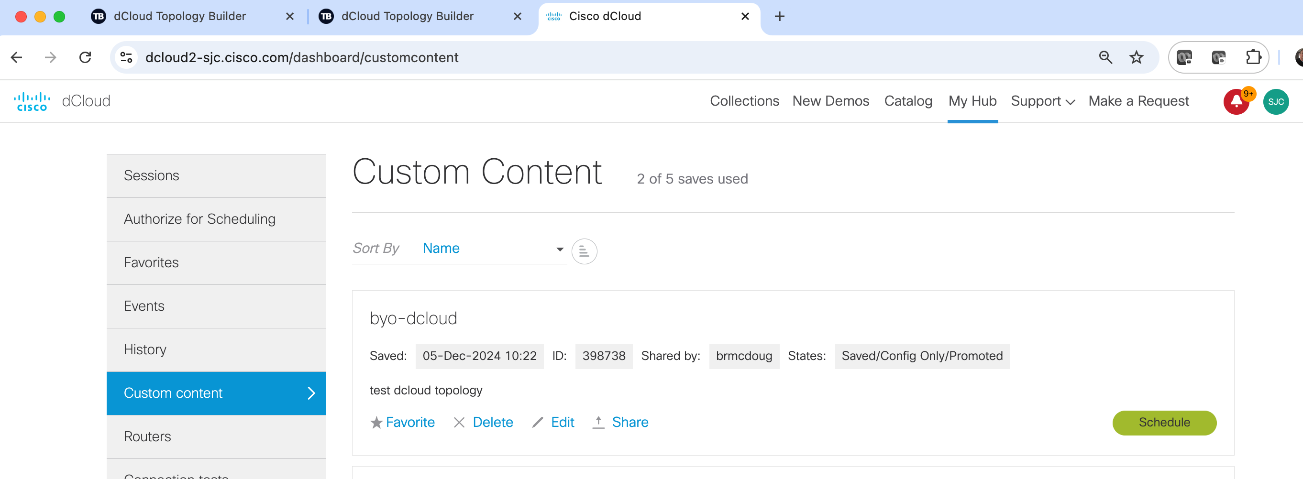

1. You can schedule the session from either the dCloud UI or the Topology Builder UI:

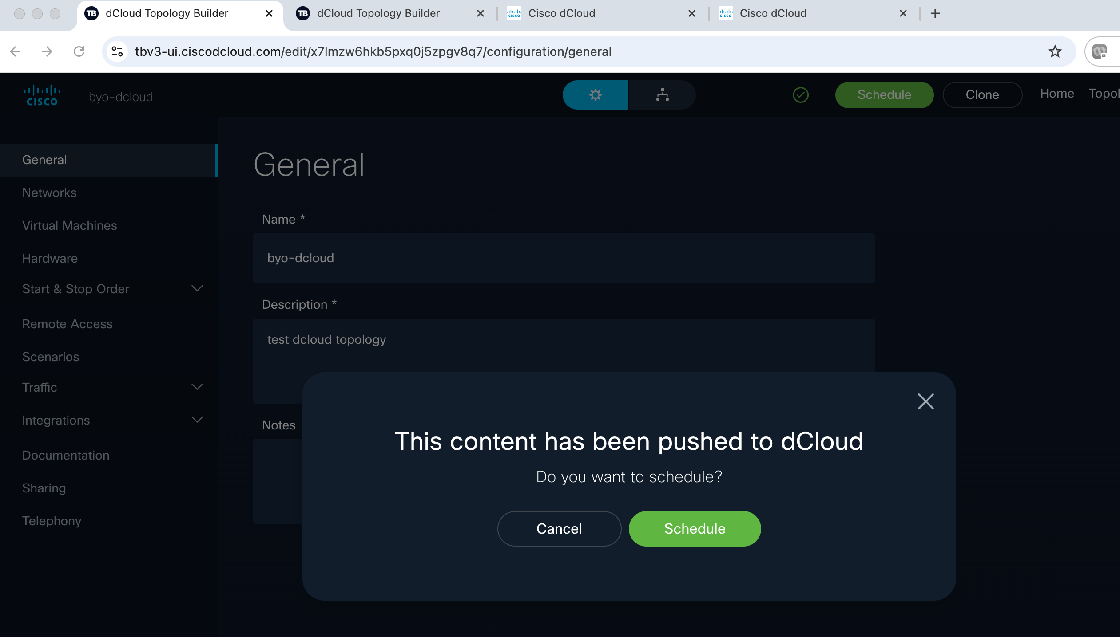

1. dCloud scheduling window…drag the bottom of the blue section down and across to schedule your session for a couple days, or simply click/edit the “End Date”, then click Next

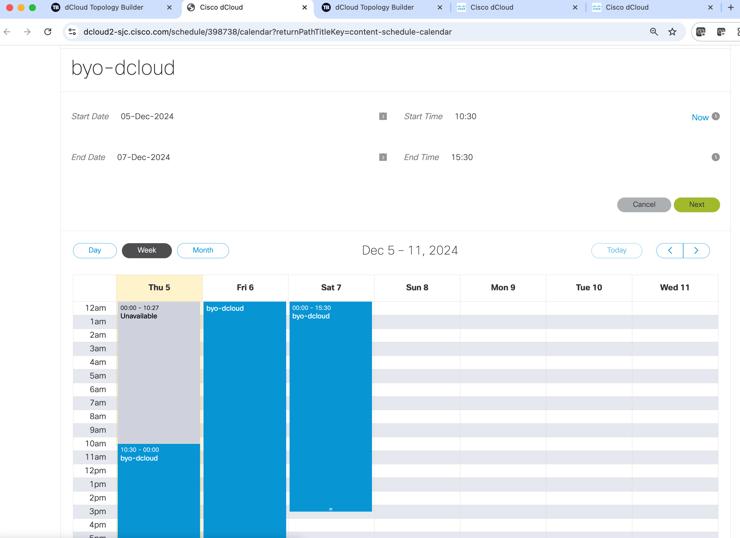

1. The “Please tell us how you will use this dcloud session screen”…Let “Primary Use” default to Customer Demo/Lab/POC/POV
2. In Account Name – Country enter the country where your customer is based. Then type in customer name. The tool should provide a drop down of options for customer location. Select one of them:

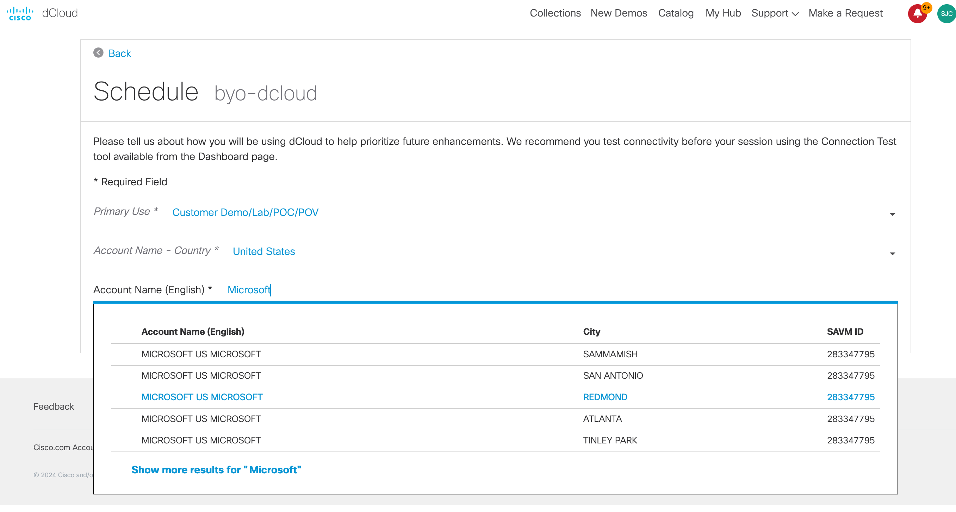

1. Click Schedule:

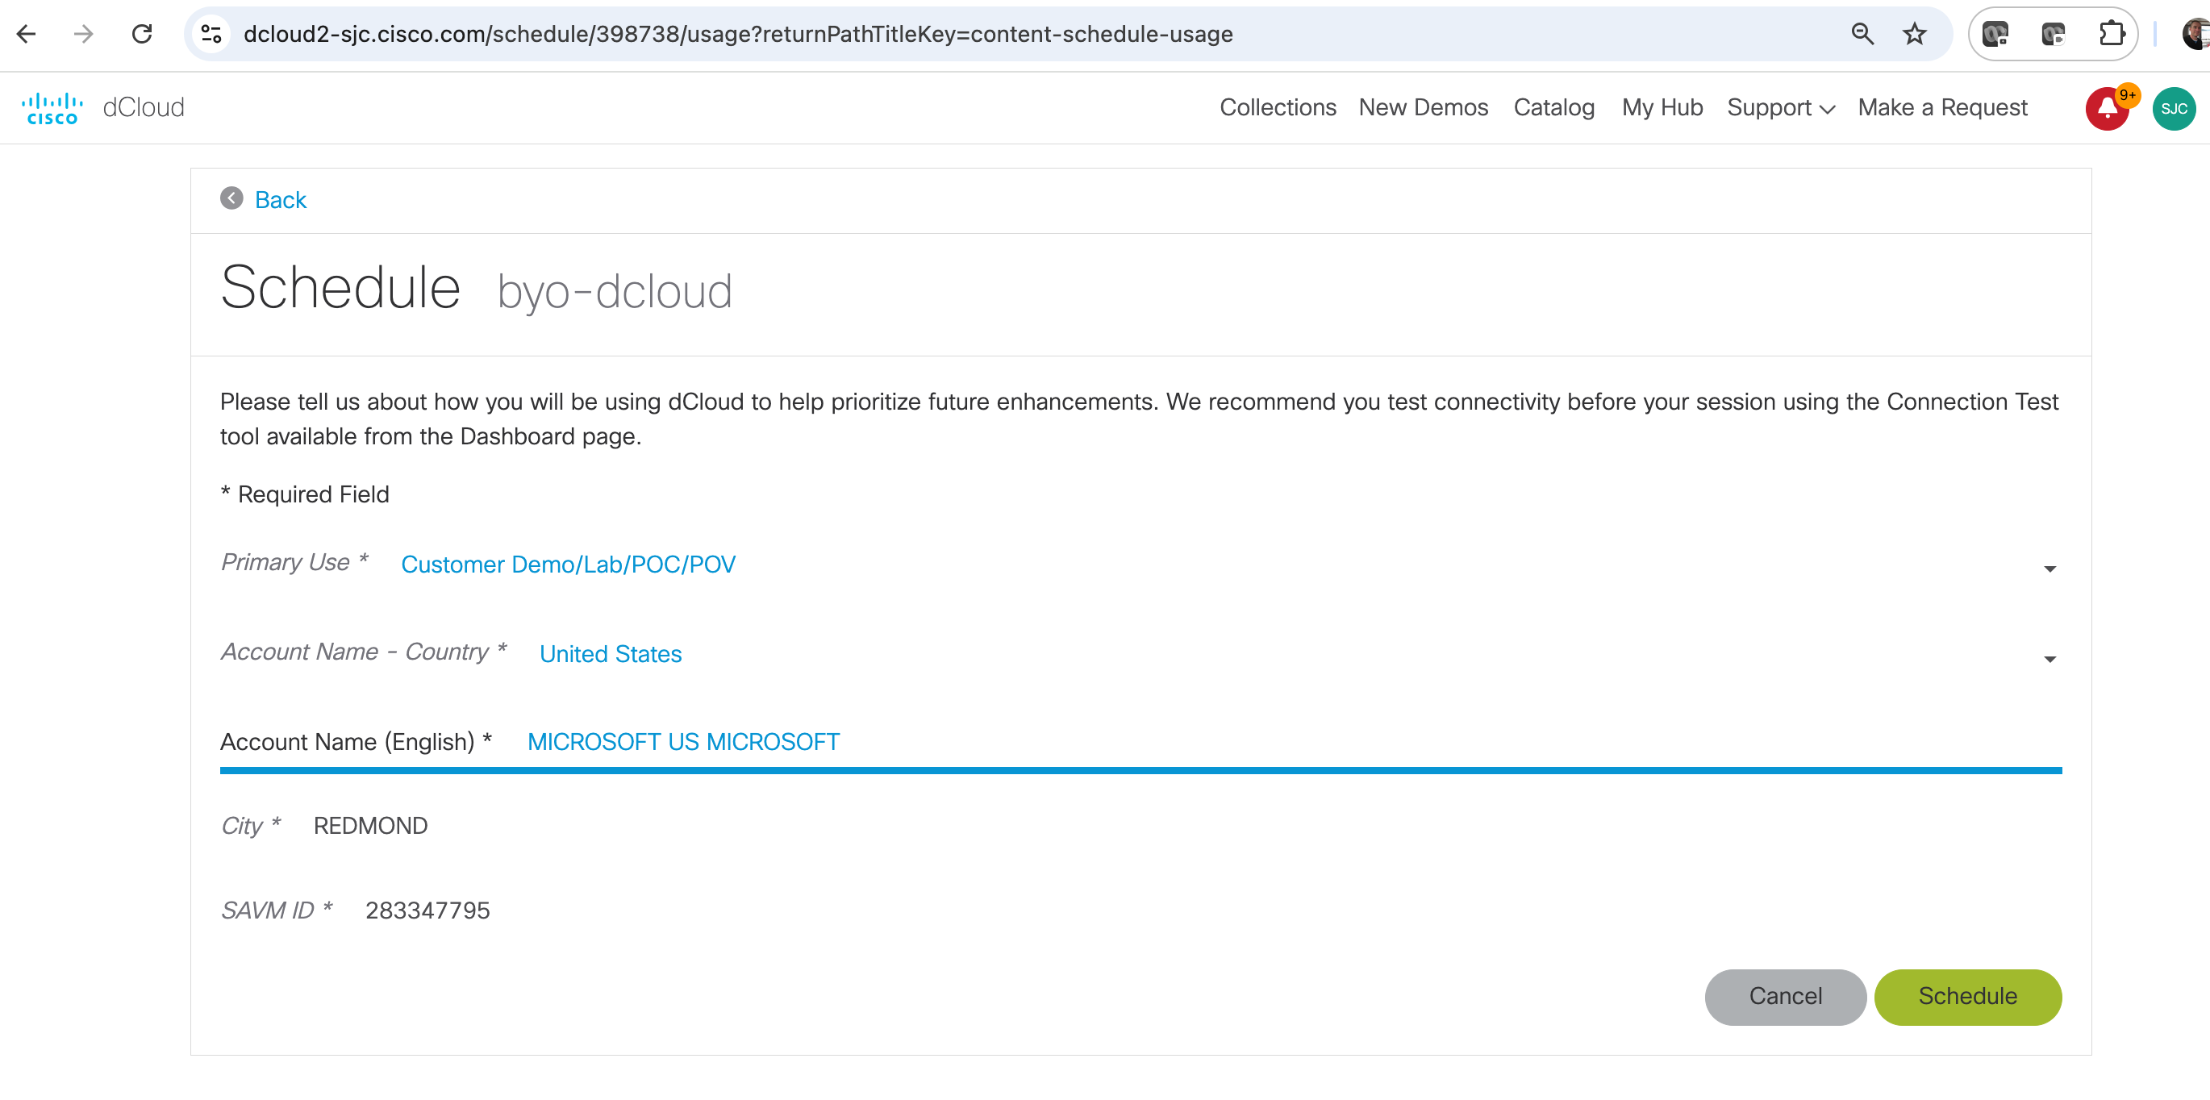

1. dCloud session will start at the time shown…we may get to wait a few minutes. Coffee break

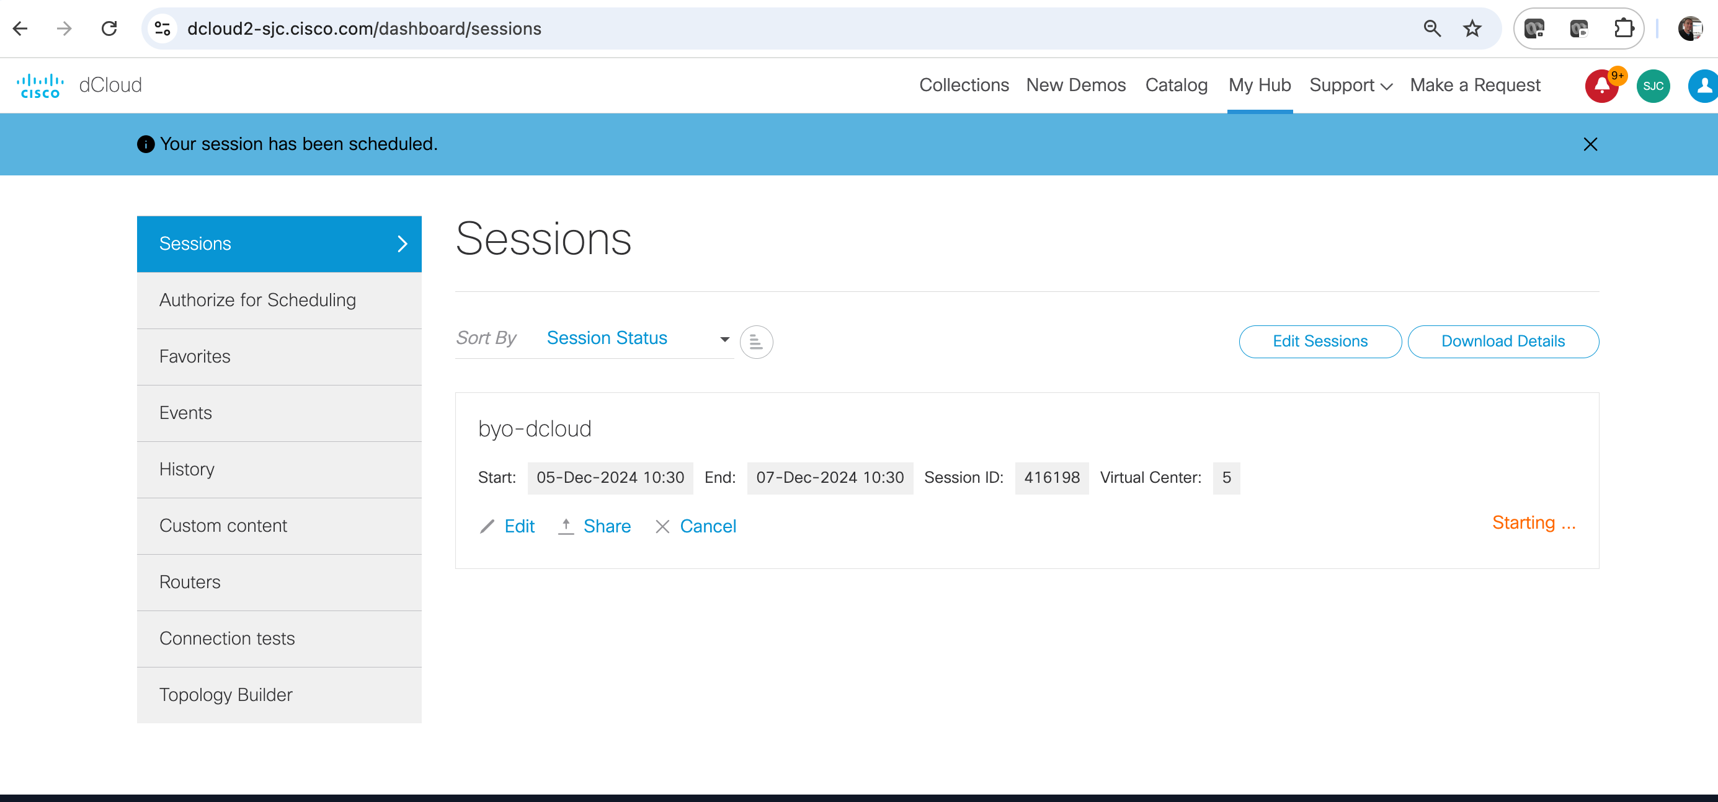

1. Once the Session has started we can AnyConnect VPN in. Click “Info” then scroll down to AnyConnect Credentials.

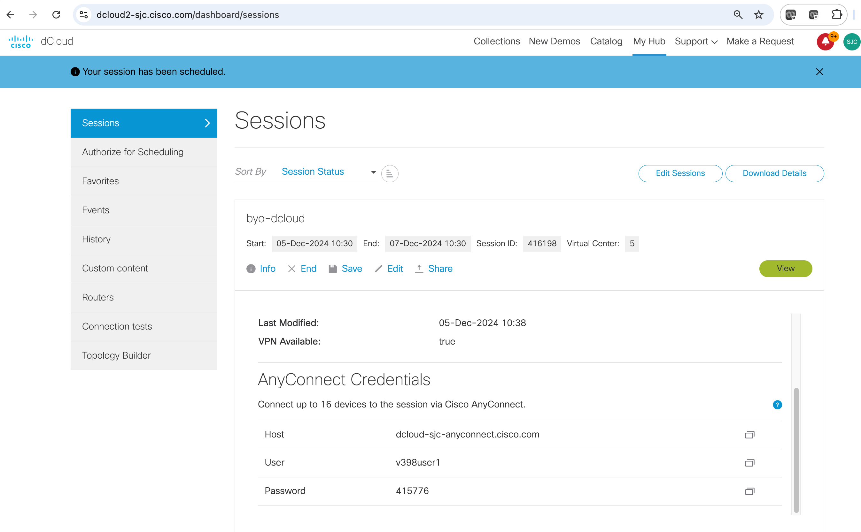

1. Optionally you can click the green View button, which will open a new topology view tab. Click “Info” and scroll down on the left hand menu to see AnyConnect Credentials here as well:

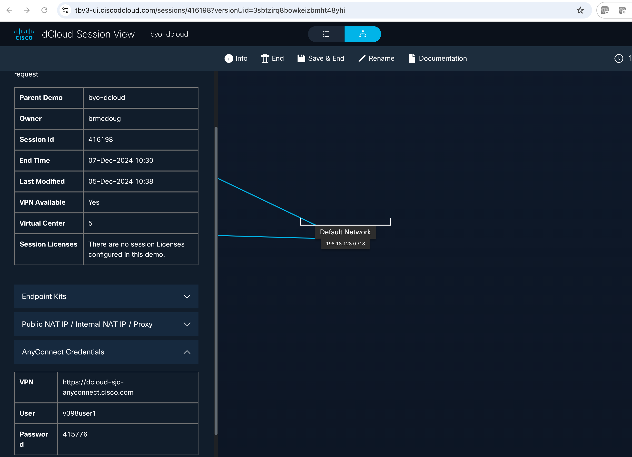

1. Fire up your VPN:

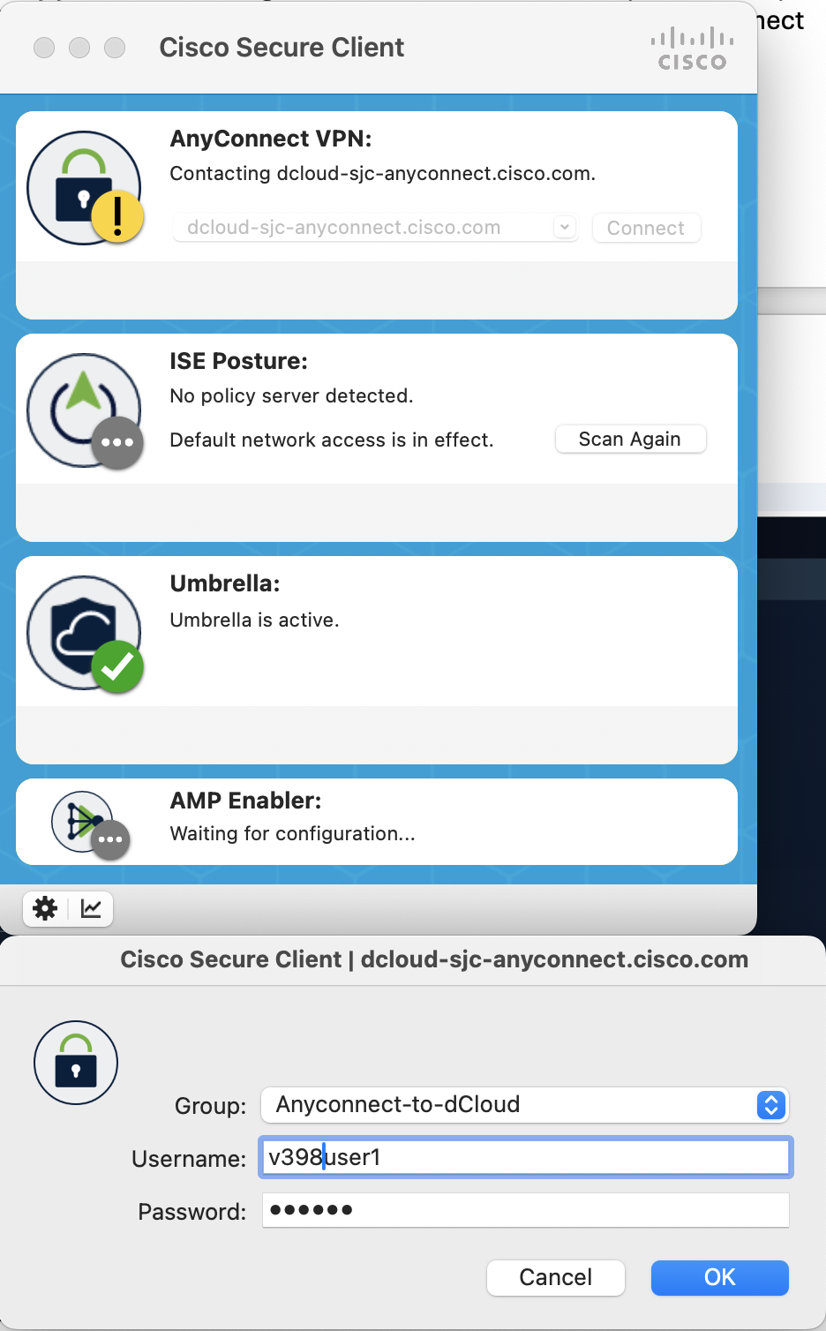

## Part 2 – Containerlab and XRd

1. Once connected to VPN we can ssh to our Ubuntu VM.

**Ssh** [**dcloud@198.18.133.100**](mailto:dcloud@198.18.133.100)

**Password = C1sco12345**

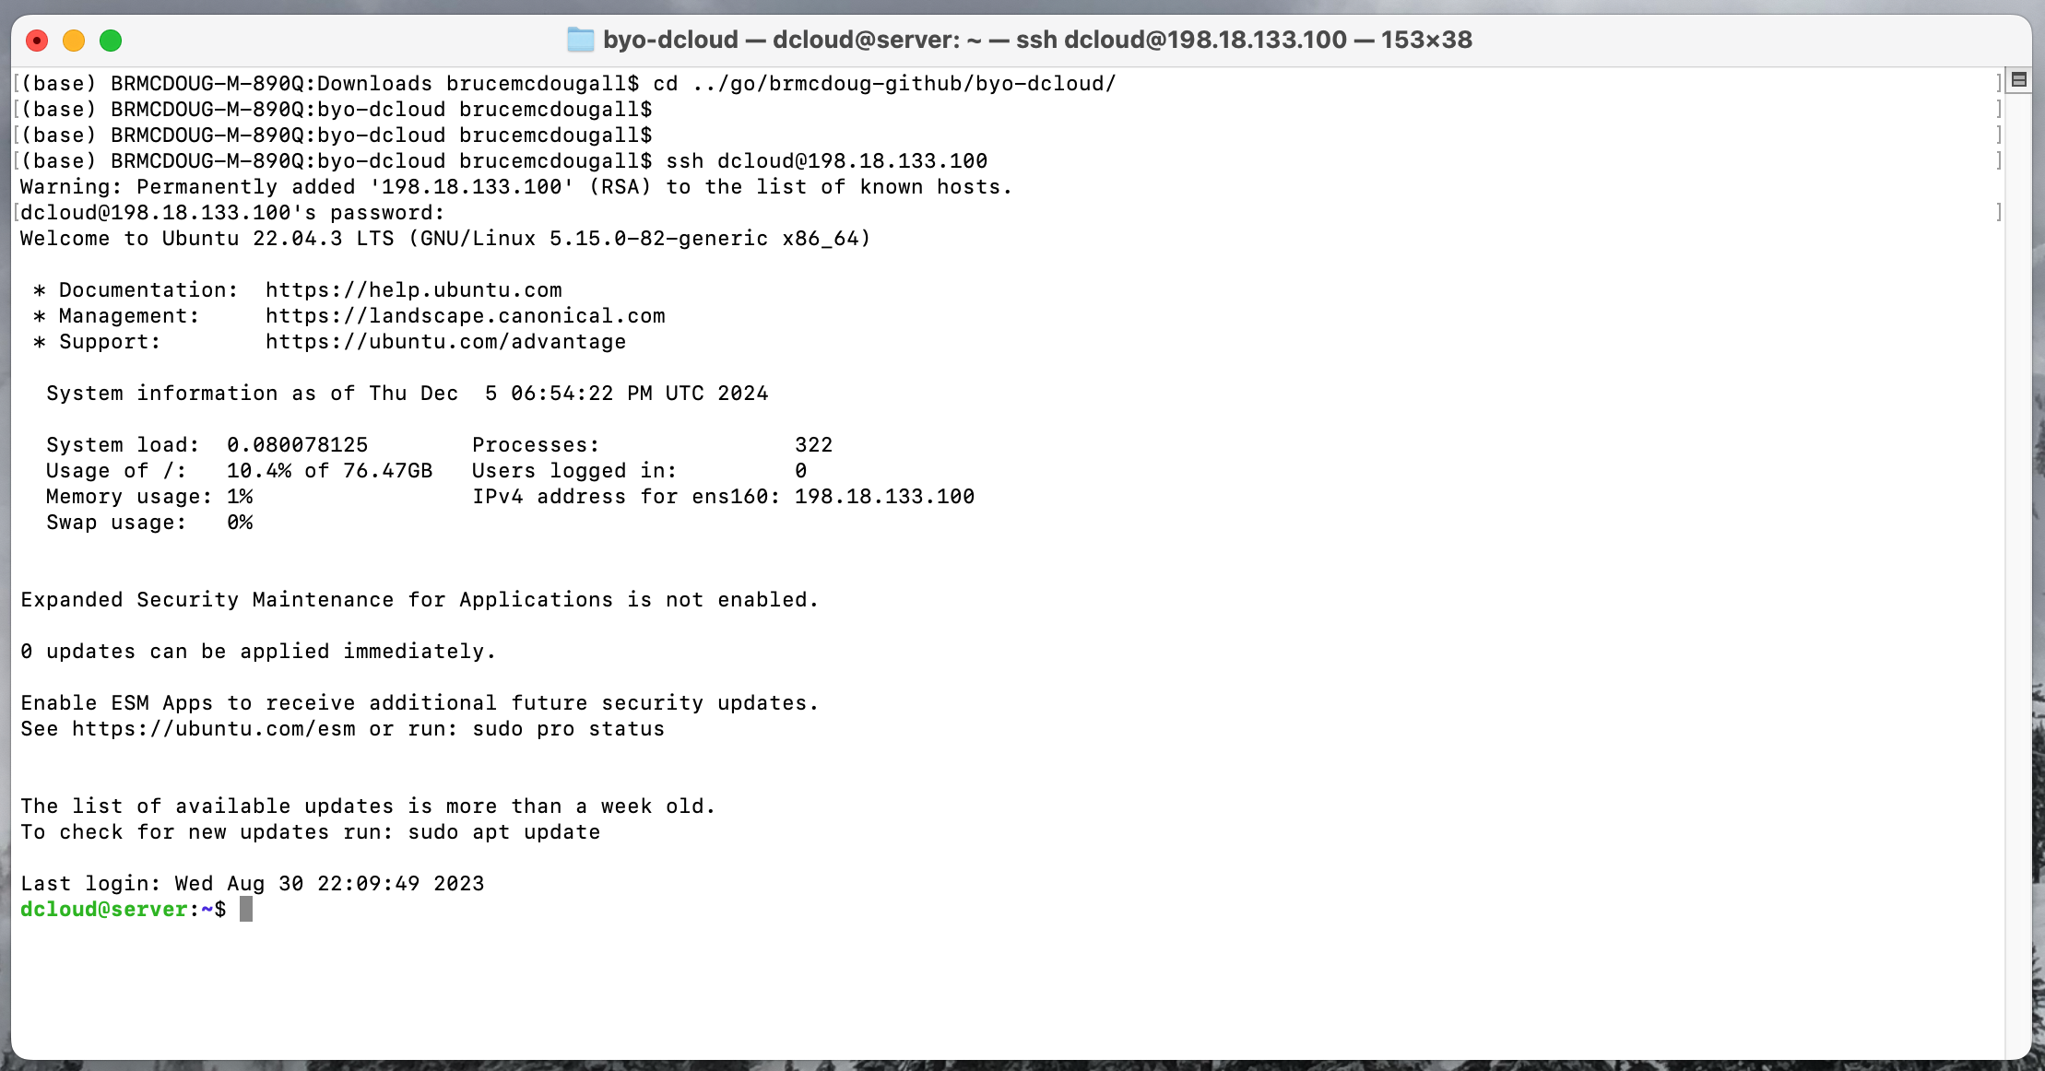

1. Optional: change hostname and your password to something easier to type:

* vi or nano /etc/hostname and /etc/hosts
* passwd command

1. We’ll use the open-source tool Containerlab to build/deploy our XRd network:

Containerlab homepage: <https://containerlab.dev/>

1. Install Containerlab: <https://containerlab.dev/install/>

Scroll down to the Quick Setup section and copy the curl setup command:

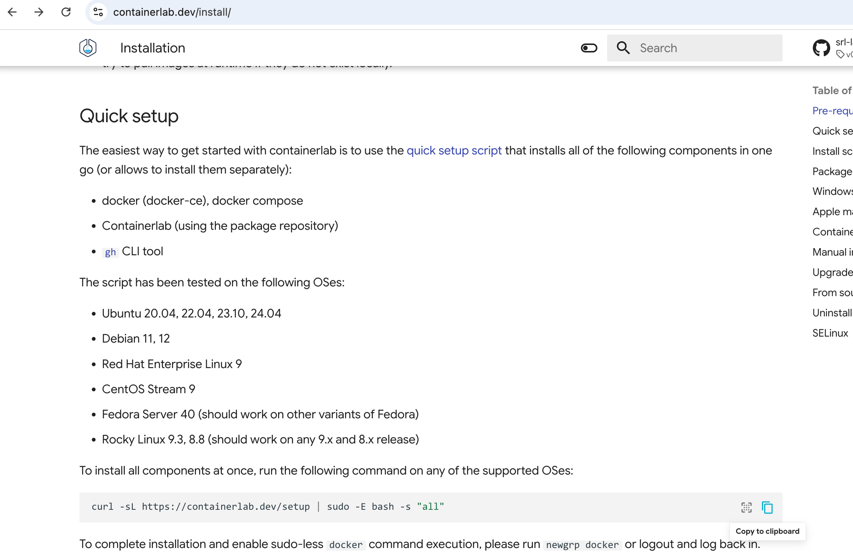

1. Paste the command into your ssh session. The installation script will check for dependencies and install packages such as Docker and containerd. Once the script completes run “sudo clab version”. Example:

**dcloud@server**:**~**$ sudo clab version

____ ___ _ _ _____ _ ___ _ _ _____ ____ _ _

/ ___/ _ \| \ | |_ _|/ \ |_ _| \ | | ____| _ \| | __ _| |__

| | | | | | \| | | | / _ \ | || \| | _| | |_) | |/ _` | '_ \

| |__| |_| | |\ | | |/ ___ \ | || |\ | |___| _ <| | (_| | |_) |

\____\___/|_| \_| |_/_/ \_\___|_| \_|_____|_| \_\_|\__,_|_.__/

version: 0.60.0

commit: 53c2ce42

date: 2024-12-05T18:11:54Z

source: https://github.com/srl-labs/containerlab

rel. notes: https://containerlab.dev/rn/0.60/

**dcloud@server**:**~**$